Redirecting Output (> and >>)

ls > files.txt

cat files.txt

Append instead of overwrite

echo "New entry" >> files.txt

Redirecting Input (<)

echo -e "banana\napple\ncherry" > fruits.txt
-e interprets escape characters..

Redirecting Errors (2>)

ls /not_a_real_folder 2> errors.txt

Pipes (|)
ls | wc -l

Filter processes

ps aux | grep bash

Check with
Ps a
Ps au
Ps aux

Ps aux | grep bash

Multi-stage Pipeline

du -sh * | sort -rh | head -5

Du -sh *

du -sh * | sort -rh

du -sh * | sort -rh | head -5

du -sh * | sort | head -5

Silent Execution will Suppress output

./script.sh > /dev/null 2>&1
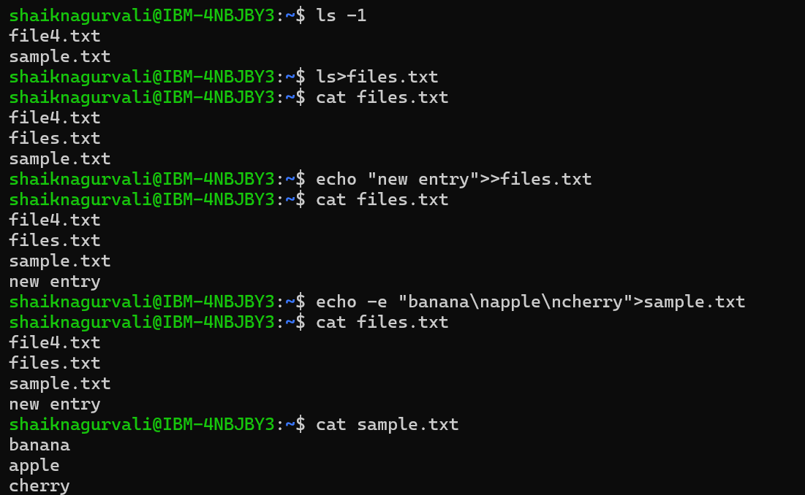

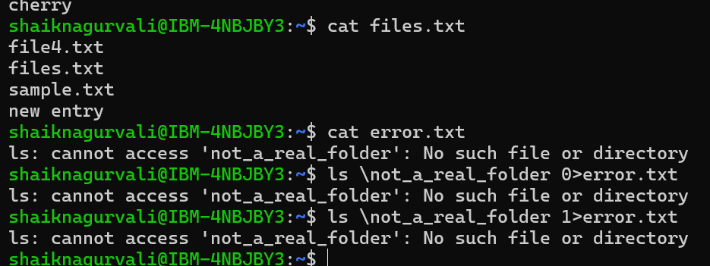

ps aux
Displays all currently running processes on the system.
- a → processes for all users
- u → display processes in user-oriented format
- x → include processes not attached to a terminal

ps aux | grep bash
Get all running processes and search for processes containing bash.

grep bash
grep bash
Searches the input for the word bash.
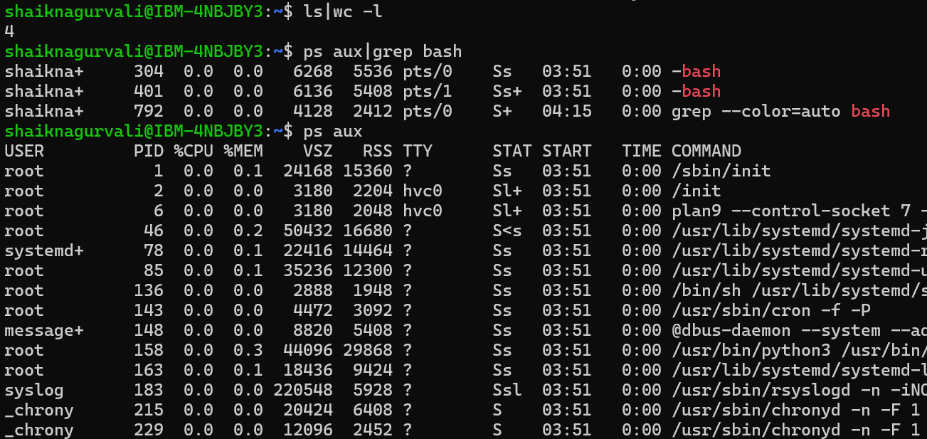

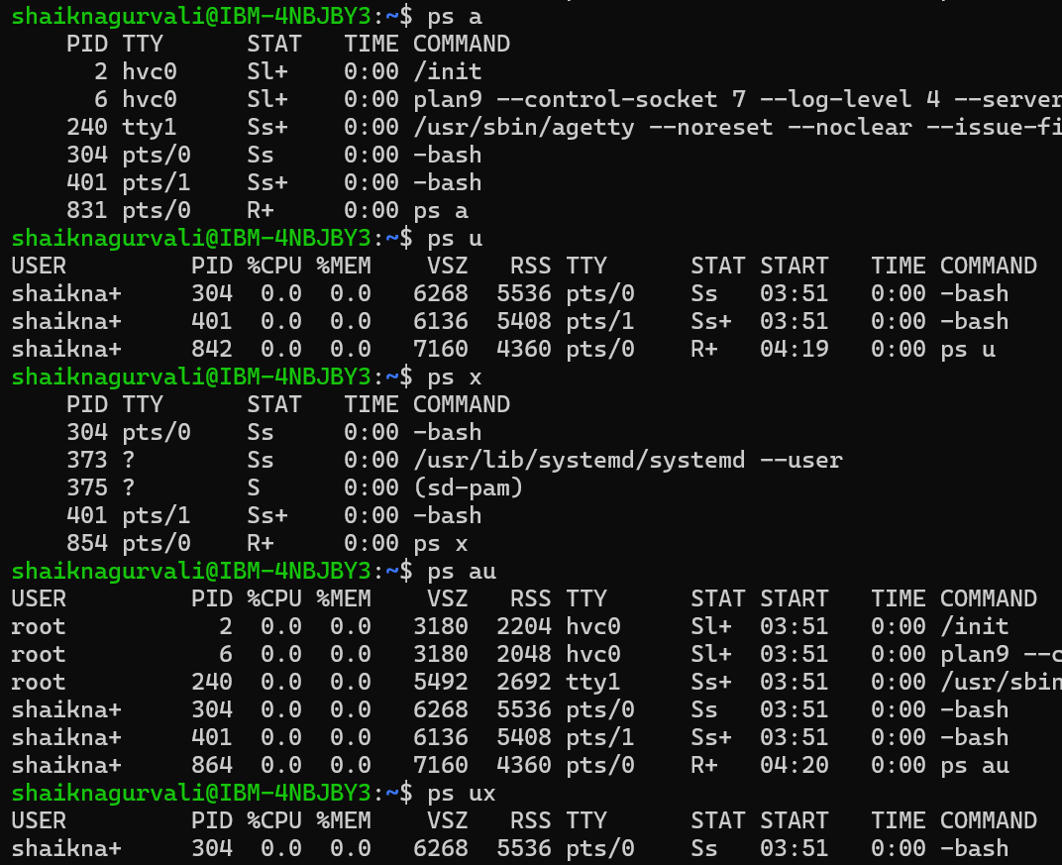

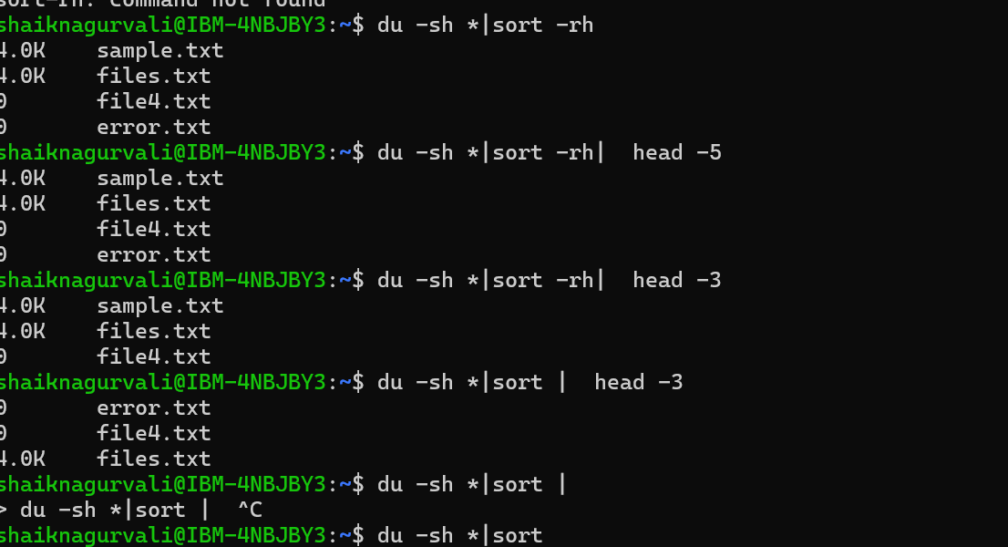

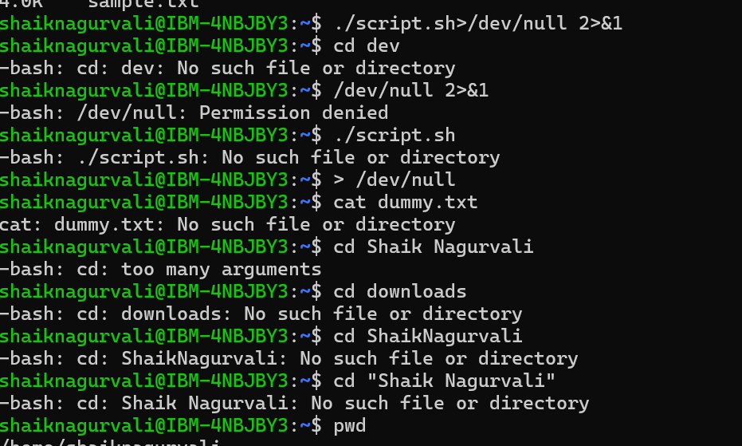
Task 1:

Sed

Go to https://www.lipsum.com/

Pick some dummy data .. and keep it in a file filename.txt

- What will this command do
Sed filename.txt

- Can you replace a word with another

S → search for 1st occurrence of any old keyword and change it with new in your file..

sed 's/old/new/' filename

- G flag → for all occurrences of the word and change it to new word.

sed 's/old/new/g' filename

- Try with delete flag
sed '/word/d' filename

- Print specific line numbers line line 3 of your file

sed -n '3p' filename

- Print range of lines

Like from line 2 to 5
sed -n '2,5p' filename
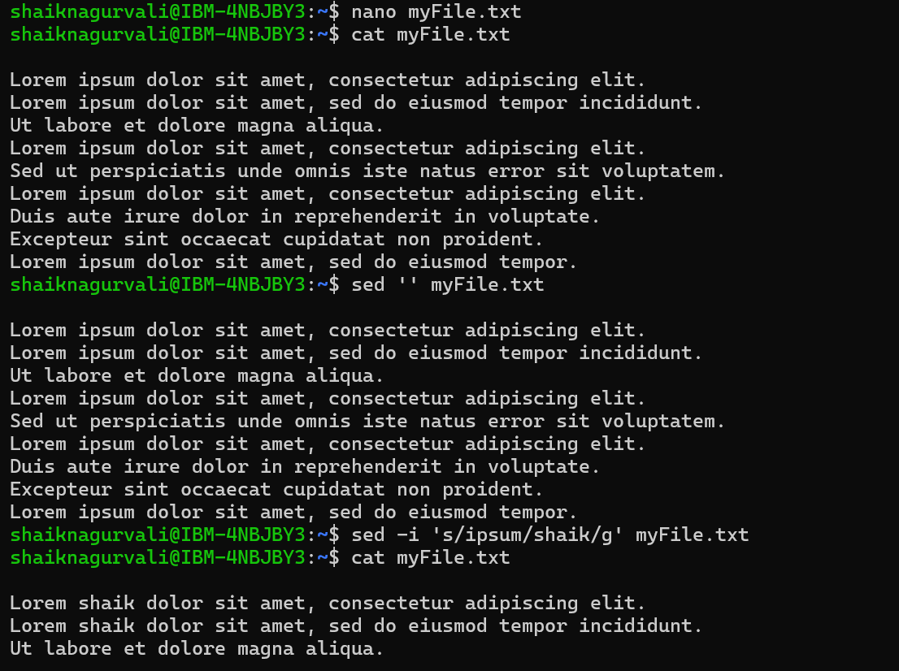

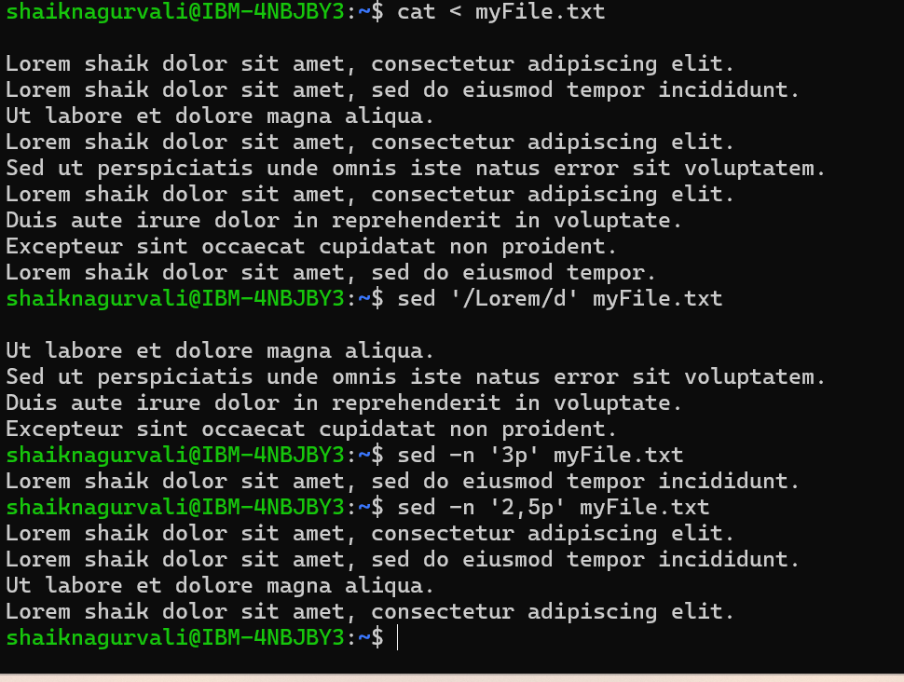

Task 2:

Awk (used for pattern scanning and processing)

- Now try same with awk
awk '{print}' filename

- Print specific column
awk '{print $2}' filename

- Print multiple columns
awk '{print $1, $3}' filename

- Filter rows by giving condition
Like print 1st nd 3rd column only if 3rd column value is > 50 fo example..

awk '$3 > 50 {print $1, $3}' filename

- Use custom delimiter (comma , is a delimiter operator) and print first 2 fields..

awk -F, '{print $1, $2}' filename (here f is filed separator (demiliter))

- Now count lines
awk 'END {print NR}' filename (nr is no of records..)

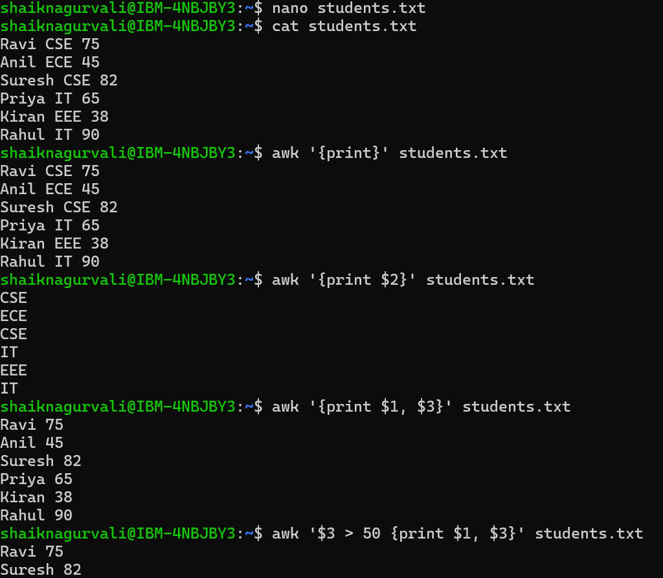

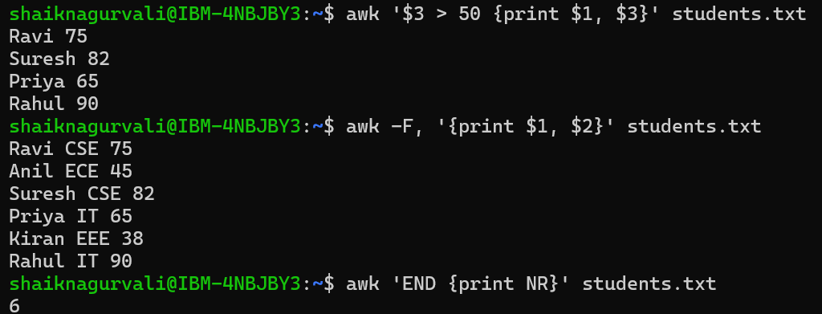

Task 3:

Ping google.com

Curl https://google.com

Netstat -an

Task 4:

Install open ssl in your system

https://www.xolphin.com/support/OpenSSL/OpenSSL_-_Installation_under_Windows#:~:text=Download%20the%20OpenSSL%20for%20Windows,file%20can%20be%20downloaded%20here.

Or

https://slproweb.com/products/Win32OpenSSL.html

Step 2 Generate a certificate signing request (CSR)

openssl genrsa -out localhost.key 2048
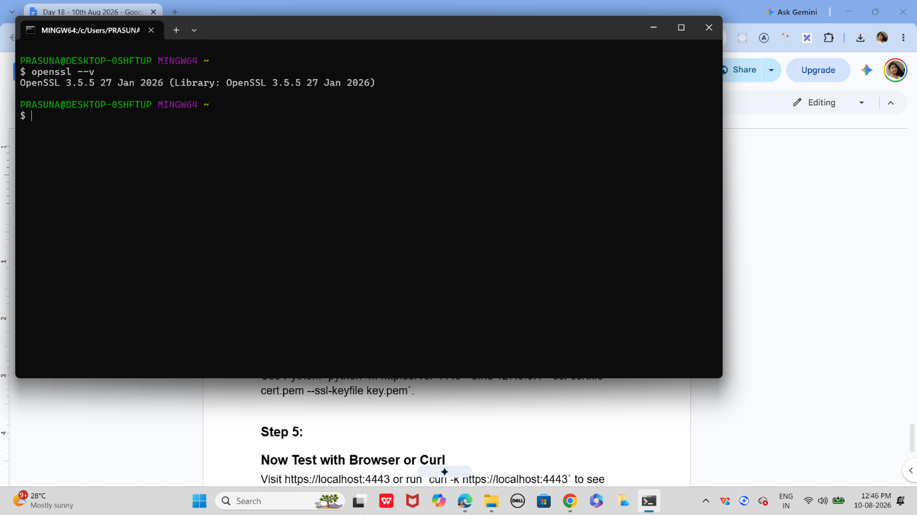

Step 3:

Generate a self-signed certificate
In bash
openssl x509 -req -days 365 -in localhost.csr -signkey localhost.key -out localhost.crt

Step 4:

Now Start a Simple HTTPS Server
Use Python: `python -m http.server 4443 --bind 127.0.0.1 --ssl-certfile cert.pem --ssl-keyfile key.pem`.

Step 5:
Now Test with Browser or Curl
Visit https://localhost:4443 or run `curl -k https://localhost:4443` to see encrypted communication.

Step 6:

Did u Observe TLS Handshake
Use Wireshark or `openssl s_client -connect localhost:4443` to watch how TLS negotiates keys and ciphers.

Step 7:

Verify Certificate Trust
Browsers will warn about self-signed certs; in real deployments, use CA-issued certificates for trust.
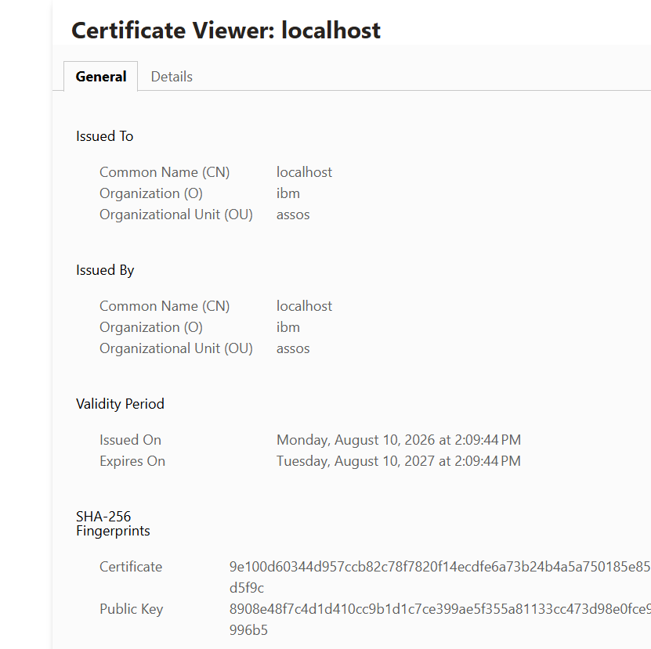

Task 5: What are Trees? Where do you implement them?
What is a Tree?
A tree is a non-linear data structure used to represent data in a hierarchical relationship.
Unlike an array or linked list, where data is arranged sequentially, a tree has nodes connected through edges
Where are trees implemented?
Trees are commonly used in:
1. File systems
Computer
|
├── Documents
│ ├── file1.txt
│ └── file2.txt
|
└── Pictures
└── photo.jpg
2. Databases
Trees such as B-Trees and B+ Trees are used for efficient indexing and searching.
3. Searching
Binary Search Trees can efficiently store and search ordered data.
4. Compilers
Syntax trees/Abstract Syntax Trees are used to represent program structure.
5. HTML/XML
Web pages and XML documents have a hierarchical structure that can be represented as trees.
6. AI and machine learning
Decision trees are used for classification and prediction.
Task 6: What are the types of Trees?
There are several types of trees.
1. General Tree
A node can have any number of children.
A
/ | \
B C D
/ \
E F

2. Binary Tree
Each node can have at most two children.
10
/ \
5 20
/ \
3 7
The two children are generally called:
Left Child
Right Child

3. Binary Search Tree — BST
A Binary Search Tree follows a specific ordering rule:
Left subtree < Root < Right subtree
Example:
50
/ \
30 70
/ \ / \
20 40 60 80
We'll discuss this in Task 7.

4. Full Binary Tree
Every node has either:
- 0 children, or
- 2 children
Example:
10
/ \
5 20
/ \
3 7
There is no node with only one child.

5. Complete Binary Tree
All levels are completely filled except possibly the last level, and the last level is filled from left to right.
10
/ \
20 30
/ \ /
40 50 60

6. Balanced Tree
The height of the left and right subtrees is kept reasonably balanced.
Examples include:
- AVL Tree
- Red-Black Tree
Balanced trees help maintain efficient searching and insertion.

7. AVL Tree
An AVL tree is a self-balancing Binary Search Tree.
After insertion or deletion, it can perform rotations to maintain balance.

8. Heap
A heap is a special type of complete binary tree.
Two common types:
Min Heap → smallest element at root
Max Heap → largest element at root
Heaps are commonly used in priority queues.
Quick summary
Tree
├── General Tree
├── Binary Tree
│
├── Binary Search Tree
├── Full Binary Tree
├── Complete Binary Tree
├── Balanced Tree
│ ├── AVL Tree
│ └── Red-Black Tree
│
└── Heap
├── Min Heap
└── Max Heap

Task 7: What is a Binary Search Tree?
A Binary Search Tree, or BST, is a Binary Tree that maintains an ordering rule.
For every node:
Values in left subtree < Node < Values in right subtree
Example:
50
/ \
30 70
/ \ / \
20 40 60 80
For node 50:
Left side → 20, 30, 40
Right side → 60, 70, 80
Therefore:
20 < 30 < 40 < 50 < 60 < 70 < 80
Searching in a BST
Suppose we want to search for 60.
Start at:
50
Is 60 > 50?
Yes → go right.
50
\
70
Is 60 < 70?
Yes → go left.
70
/
60
We found 60.
So instead of checking every node, we eliminate part of the tree at each step.
BST operations
The main operations are:
Insertion
Deletion
Searching
Traversal
Time complexity
For a balanced BST:
Search → O(log n)
Insertion → O(log n)
Deletion → O(log n)
But if the tree becomes completely unbalanced:
10
\
20
\
30
\
40
it behaves similarly to a linked list, and operations can become:
O(n)
Important property: Inorder traversal
One very important feature of a BST is that inorder traversal gives the values in sorted order.
For:
50
/ \
30 70
/ \ / \
20 40 60 80
Inorder traversal:
20 30 40 50 60 70 80
Simple answer for speaking
"A Binary Search Tree is a binary tree where the values in the left subtree are smaller than the root and the values in the right subtree are greater than the root. This property makes searching, insertion, and deletion efficient, typically O(log n) when the tree is balanced. Inorder traversal of a BST produces the elements in sorted order."
⭐ Remember these 3 points for BST
Left < Root < Right

Balanced BST:
Search → O(log n)
Insert → O(log n)
Delete → O(log n)

Inorder traversal → Sorted order
Task 8: Create a Binary Tree and Insert Values
A simple binary tree has a Node containing:
- val → value
- left → left child
- right → right child
Java program
class Node {
int val;
Node left, right;

Node(int val) {
this.val = val;
}
}

public class BinaryTree {

public static void main(String[] args) {

Node root = new Node(10);

root.left = new Node(5);
root.right = new Node(20);

root.left.left = new Node(3);
root.left.right = new Node(7);

root.right.left = new Node(15);
root.right.right = new Node(25);

System.out.println("Root: " + root.val);
System.out.println("Left child: " + root.left.val);
System.out.println("Right child: " + root.right.val);
}

Task 9: Search a Number in the BST
We already have this tree:
10
/ \
5 20
/ \ / \
3 7 15 25
We can create a search() method.
class TreeNode {
int val;
TreeNode left;
TreeNode right;

TreeNode(int val) {
this.val = val;
}
}

public class BinaryTree {

static boolean search(TreeNode root, int key) {

if (root == null) {
return false;
}

if (root.val == key) {
return true;
}

if (key < root.val) {
return search(root.left, key);
}

return search(root.right, key);
}

public static void main(String[] args) {

TreeNode root = new TreeNode(10);

root.left = new TreeNode(5);
root.right = new TreeNode(20);

root.left.left = new TreeNode(3);
root.left.right = new TreeNode(7);

root.right.left = new TreeNode(15);
root.right.right = new TreeNode(25);

int key = 15;

if (search(root, key)) {
System.out.println(key + " found");
} else {
System.out.println(key + " not found");
}
}
}
Output
15 found
How it searches
For 15:
10
\
20
/
15
- 15 > 10 → go right
- 15 < 20 → go left
- 15 == 15 → found
Simple explanation
In a BST, we compare the search value with the current node. If it is smaller, we go left; if it is larger, we go right. This continues until the value is found or the tree ends.

Task 10: Inorder Traversal in BST
Inorder traversal means:
Left → Root → Right
Add this method:
static void inorder(TreeNode root) {

if (root == null) {
return;
}

inorder(root.left);

System.out.print(root.val + " ");

inorder(root.right);
}
Complete program:
class TreeNode {
int val;
TreeNode left;
TreeNode right;

TreeNode(int val) {
this.val = val;
}
}

public class BinaryTree {

static void inorder(TreeNode root) {

if (root == null) {
return;
}

inorder(root.left);
System.out.print(root.val + " ");
inorder(root.right);
}

public static void main(String[] args) {

TreeNode root = new TreeNode(10);

root.left = new TreeNode(5);
root.right = new TreeNode(20);

root.left.left = new TreeNode(3);
root.left.right = new TreeNode(7);

root.right.left = new TreeNode(15);
root.right.right = new TreeNode(25);

System.out.println("Inorder traversal:");

inorder(root);
}
}

Output
Inorder traversal:
3 5 7 10 15 20 25
⭐ Important: Inorder traversal of a BST gives the values in sorted order.

Task 11: Difference Between BFS and DFS

BFS — Breadth First Search
BFS visits nodes level by level.
A
/ \
B C
/ \ \
D E F
BFS:
A → B → C → D → E → F

DFS — Depth First Search
DFS goes as deep as possible before coming back.
One possible DFS:
A → B → D → E → C → F

Main difference
BFS | DFS
Breadth first | Depth first
Level by level | Goes deep first
Uses Queue | Uses Stack/Recursion
Useful for shortest path in unweighted graph | Useful for exploring paths/cycles

Interview answer
BFS explores a graph level by level, whereas DFS explores as deeply as possible before backtracking.

Task 12: Data Structures Used by BFS and DFS

BFS
Uses a Queue.
Queue
FIFO
First In → First Out

DFS
Uses a Stack or recursion.
Stack
LIFO
Last In → First Out

Interview answer
BFS uses a Queue, while DFS uses a Stack or recursion.
A · start · neighbors A–Z
A#1
B#2
C#3
D#4
E#5
F#6
A#1
B#2
C#3
D#4
E#5
F#6
FIFO queueDEFfront → back
● current◌ frontier● explored┄ unreached / non-tree edge
Finish the distance-one layer
C discovers F. Every distance-one vertex is processed before the distance-two frontier.
Algorithm
BFSDFS
BFSDFS
Give feedback

Task 13: Shortest Path in an Unweighted Graph
For an unweighted graph, we use BFS.
Example:
A ─ B ─ C
|
D
Starting from A, BFS checks nodes level by level.
If we want to reach D:
A → B → D
This is the shortest path in terms of number of edges.

Interview answer
We use BFS to find the shortest path in an unweighted graph because BFS visits nodes level by level, so the first time we reach a node is through the shortest path.

Task 14: Detect a Cycle in a Graph
The approach depends on the graph type.

Undirected graph
Use DFS/BFS + visited array + parent tracking.
If we find a visited node that is not the current node's parent, a cycle exists.
Example:
A ─ B
| |
└── C
There is a cycle:
A → B → C → A

Directed graph
Use DFS + recursion stack.
If we encounter a node that is already in the current recursion stack, a cycle exists.

Interview answer
For an undirected graph, we can use DFS with a parent check. For a directed graph, we can use DFS with a recursion stack to detect a cycle.

Task 15: Internal Working of HashMap
A HashMap stores data as:
Key → Value
Example:
HashMap<Integer, String> map = new HashMap<>();

map.put(101, "Ravi");
map.put(102, "Anil");
Internally:
Key
↓
hashCode()
↓
Hash
↓
Bucket
↓
Key + Value
When we execute:
map.get(101);
Java calculates the hash of 101, finds the appropriate bucket, and searches for the key.

Interview answer
HashMap uses the key's hash code to determine a bucket where the key-value pair is stored. During retrieval, it calculates the hash again and uses equals() to identify the correct key.

Task 16: HashMap Property Used for Array Intersection
The important property is fast lookup.
Suppose:
Array 1 = [1, 2, 3, 4]
Array 2 = [3, 4, 5, 6]
Store the first array's elements in a hash-based structure.
Then check the second array:
3 → found
4 → found
5 → not found
6 → not found
Therefore:
Intersection = [3, 4]

Interview answer
Hash-based lookup provides fast average-case searching, so we can efficiently check whether an element from one array exists in another.
For this specific problem, HashSet is generally preferable to HashMap.

Task 17: What is Collision in HashMap?
A collision occurs when two different keys map to the same bucket.
For example:
Key A → Bucket 5
Key B → Bucket 5
Both keys want to use the same bucket.
Java handles this using a bucket structure containing multiple entries. With sufficiently many collisions and depending on the table conditions, modern Java can convert a heavily-colliding bucket to a balanced tree.

Interview answer
A collision occurs when different keys map to the same HashMap bucket. Java handles these multiple entries within the bucket and may treeify heavily-colliding buckets.

Task 18: Capacity vs Size of HashMap

Size
The size is the number of key-value pairs currently stored.
Example:
map.put(1, "A");
map.put(2, "B");
map.put(3, "C");
Then:
size = 3
You can get it using:
map.size();

Capacity
Capacity refers to the number of buckets in the internal hash table.
For example, conceptually:
Capacity = 16
Size = 3
means the table has capacity for 16 buckets while only 3 entries are currently stored.

Interview answer
Size represents the number of entries currently stored, while capacity represents the number of buckets available in the internal hash table.

Task 19: Does HashMap Allow Null Values?

Yes. ✅
A Java HashMap allows:
- One null key
- Multiple null values
Your program:
import java.util.*;

public class InterviewBit {

public static void main(String[] args) {

HashMap hmap = new HashMap();

hmap.put(1, "Program to store null value");
hmap.put(null, "InterviewBit");

System.out.println(hmap);
}
}

Output
The map contains:
{null=InterviewBit, 1=Program to store null value}
The order is not guaranteed, so the entries may appear in the opposite order.

2-line answer
HashMap allows one null key and multiple null values. In this example, the null key stores "InterviewBit" and key 1 stores "Program to store null value".

Task 20: Why is HashMap Not Thread-Safe?
Normal HashMap is not thread-safe.
Suppose multiple threads access it:
Thread 1 → put()
Thread 2 → put()
Thread 3 → get()
There is no built-in synchronization in a normal HashMap.
Concurrent modification can therefore cause race conditions or inconsistent results.
For concurrent access, we can use:
ConcurrentHashMap

Example
ConcurrentHashMap<Integer, String> map =
new ConcurrentHashMap<>();

Interview answer
HashMap is not thread-safe because its operations are not synchronized. When multiple threads access or modify it concurrently, race conditions can occur. ConcurrentHashMap can be used for thread-safe concurrent access.

Task 21: Can Multiple Keys Have the Same Value?

Yes. ✅
Keys must be unique, but values can be duplicated.
import java.util.*;

public class Test {

public static void main(String[] args) {

HashMap<Integer, String> map = new HashMap<>();

map.put(1, "Java");
map.put(2, "Java");
map.put(3, "Python");

System.out.println(map);
}
}
Output:
{1=Java, 2=Java, 3=Python}
Here:
1 → Java
2 → Java
Two different keys have the same value.
But if we use the same key:
map.put(1, "Java");
map.put(1, "Python");
The second value replaces the first:
1 → Python

Interview answer
Yes, multiple keys can have the same value in a HashMap, but each key must be unique. If the same key is inserted again, its previous value is replaced.

Task 22: HashMap vs Hashtable in Java
Both HashMap and Hashtable store data as key-value pairs.
Main differences
Feature | HashMap | Hashtable
Thread-safe | ❌ No | ✅ Yes
Synchronized | ❌ No | ✅ Yes
Null key | ✅ One null key | ❌ Not allowed
Null values | ✅ Multiple allowed | ❌ Not allowed
Performance | Generally faster | Generally slower
Introduced | Java 1.2 | Java 1.0
Modern usage | Commonly used | Legacy class
Example
HashMap<Integer, String> map = new HashMap<>();

map.put(1, "Java");
map.put(null, "Python");

System.out.println(map);
This works because HashMap allows a null key.
But:
Hashtable<Integer, String> table = new Hashtable<>();

table.put(null, "Java");
will throw a NullPointerException.
Interview answer
HashMap is not synchronized and allows one null key and multiple null values, whereas Hashtable is synchronized and doesn't allow null keys or values. HashMap is generally preferred for non-thread-safe use, while ConcurrentHashMap is usually preferred for modern concurrent applications.

Task 23: Bubble Sort
Concept
Bubble Sort repeatedly compares adjacent elements and swaps them if they are in the wrong order.
Example:
5 3 8 1

5 > 3 → swap

3 5 8 1
Eventually:
1 3 5 8
Java code
public class BubbleSort {

public static void main(String[] args) {

int[] arr = {5, 3, 8, 1, 2};

int n = arr.length;

for (int i = 0; i < n - 1; i++) {

for (int j = 0; j < n - i - 1; j++) {

if (arr[j] > arr[j + 1]) {

int temp = arr[j];
arr[j] = arr[j + 1];
arr[j + 1] = temp;
}
}
}

System.out.println("Sorted array:");

for (int value : arr) {
System.out.print(value + " ");
}
}
}
Output
Sorted array:
1 2 3 5 8
Complexity
Time → O(n²)
Space → O(1)
Interview answer
Bubble Sort repeatedly compares adjacent elements and swaps them if they are in the wrong order. After each pass, the largest unsorted element moves to the end.
Compare 5 and 2 → swap
Pass 1·Comparison 1 of 6·1 swap
2
5
7
1
6
3
4
1
2
3
4
5
6
7
Result: 2, 5; 5 moves one place right
Sorting step
Sorting step
Give feedback

Task 24: Selection Sort
Concept
Selection Sort finds the smallest element from the unsorted portion and places it at the beginning.
Example:
5 3 8 1 2
Smallest = 1
Swap with first element:
1 3 8 5 2
Then find the smallest from the remaining portion.
Java code
public class SelectionSort {

public static void main(String[] args) {

int[] arr = {5, 3, 8, 1, 2};

int n = arr.length;

for (int i = 0; i < n - 1; i++) {

int min = i;

for (int j = i + 1; j < n; j++) {

if (arr[j] < arr[min]) {
min = j;
}
}

int temp = arr[i];
arr[i] = arr[min];
arr[min] = temp;
}

System.out.println("Sorted array:");

for (int value : arr) {
System.out.print(value + " ");
}
}
}
Output
Sorted array:
1 2 3 5 8
Complexity
Time → O(n²)
Space → O(1)
Interview answer
Selection Sort repeatedly finds the smallest element from the unsorted portion and places it at the correct position.
Pass 1: scan the unsorted suffix
Comparison 1 of 7·0 sorted
Minimum 6Comparing 3
6
3
8
2
7
1
5
4
1
2
3
4
5
6
7
8
Compare 3 with 6; the bars stay fixed while this pass scans
Selection step
Selection step
Give feedback

Task 25: Linear Search
Concept
Linear Search checks elements one by one until the required element is found.
Example:
Array = [10, 20, 30, 40, 50]
Key = 40
Search:
10 ❌
20 ❌
30 ❌
40 ✅
Java code
public class LinearSearch {

public static void main(String[] args) {

int[] arr = {10, 20, 30, 40, 50};

int key = 40;

int result = -1;

for (int i = 0; i < arr.length; i++) {

if (arr[i] == key) {
result = i;
break;
}
}

if (result != -1) {
System.out.println(key + " found at index " + result);
} else {
System.out.println(key + " not found");
}
}
}
Output
40 found at index 3
Complexity
Time → O(n)
Space → O(1)
Interview answer
Linear Search checks each element sequentially until the target is found. It works on both sorted and unsorted arrays.

Home Task 1: Insertion Sort
Concept
Insertion Sort builds the sorted array one element at a time.
Example:
5 3 8 1 2
Take 3 and insert it before 5:
3 5 8 1 2
Then take 8:
3 5 8 1 2
Then continue.
Java code
public class InsertionSort {

public static void main(String[] args) {

int[] arr = {5, 3, 8, 1, 2};

for (int i = 1; i < arr.length; i++) {

int key = arr[i];

int j = i - 1;

while (j >= 0 && arr[j] > key) {

arr[j + 1] = arr[j];

j--;
}

arr[j + 1] = key;
}

System.out.println("Sorted array:");

for (int value : arr) {
System.out.print(value + " ");
}
}
}
Output
Sorted array:
1 2 3 5 8
Complexity
Average/Worst → O(n²)
Best → O(n)
Space → O(1)
Insertion Sort is particularly useful when the data is already nearly sorted.
Start with one sorted value
Pass 1 of 6·1 sorted
Sorted prefix
7
3
8
2
6
4
5
1
2
3
4
5
6
7
Insertion step
Insertion step
Give feedback

Home Task 2: Merge Sort
Merge Sort uses divide and conquer.
It divides the array into smaller parts, sorts them, and then merges them.
Example:
[5, 3, 8, 1]

↓

[5, 3] [8, 1]

↓ ↓

[3, 5] [1, 8]

↓

[1, 3, 5, 8]
Java code
public class MergeSort {

static void merge(int[] arr, int left, int mid, int right) {

int n1 = mid - left + 1;
int n2 = right - mid;

int[] L = new int[n1];
int[] R = new int[n2];

for (int i = 0; i < n1; i++) {
L[i] = arr[left + i];
}

for (int j = 0; j < n2; j++) {
R[j] = arr[mid + 1 + j];
}

int i = 0;
int j = 0;
int k = left;

while (i < n1 && j < n2) {

if (L[i] <= R[j]) {
arr[k] = L[i];
i++;
} else {
arr[k] = R[j];
j++;
}

k++;
}

while (i < n1) {
arr[k] = L[i];
i++;
k++;
}

while (j < n2) {
arr[k] = R[j];
j++;
k++;
}
}

static void mergeSort(int[] arr, int left, int right) {

if (left < right) {

int mid = (left + right) / 2;

mergeSort(arr, left, mid);

mergeSort(arr, mid + 1, right);

merge(arr, left, mid, right);
}
}

public static void main(String[] args) {

int[] arr = {5, 3, 8, 1, 2};

mergeSort(arr, 0, arr.length - 1);

System.out.println("Sorted array:");

for (int value : arr) {
System.out.print(value + " ");
}
}
}
Output
Sorted array:
1 2 3 5 8
Complexity
Time → O(n log n)
Space → O(n)
Interview answer
Merge Sort uses divide and conquer. It divides the array into smaller parts, recursively sorts them, and merges the sorted parts.
381227439311825
Divide
The values begin in their original order.
Merge step
Merge step
8 · even7 · uneven
8 · even7 · uneven
Give feedback

Home Task 3: Quick Sort
Quick Sort selects a pivot and partitions the array around it.
For example:
[5, 3, 8, 1, 2]
If pivot = 2:
Smaller than 2 | Pivot | Greater than 2
1 | 2 | 5 3 8
Then recursively sort the two sides.
Java code
public class QuickSort {

static void swap(int[] arr, int i, int j) {

int temp = arr[i];
arr[i] = arr[j];
arr[j] = temp;
}

static int partition(int[] arr, int low, int high) {

int pivot = arr[high];

int i = low - 1;

for (int j = low; j < high; j++) {

if (arr[j] < pivot) {

i++;

swap(arr, i, j);
}
}

swap(arr, i + 1, high);

return i + 1;
}

static void quickSort(int[] arr, int low, int high) {

if (low < high) {

int pivotIndex = partition(arr, low, high);

quickSort(arr, low, pivotIndex - 1);

quickSort(arr, pivotIndex + 1, high);
}
}

public static void main(String[] args) {

int[] arr = {5, 3, 8, 1, 2};

quickSort(arr, 0, arr.length - 1);

System.out.println("Sorted array:");

for (int value : arr) {
System.out.print(value + " ");
}
}
}
Output
Sorted array:
1 2 3 5 8
Complexity
Average → O(n log n)
Worst → O(n²)
Interview answer
Quick Sort selects a pivot, partitions the array around the pivot, and recursively sorts the two partitions. Its average time complexity is O(n log n), but its worst case is O(n²).
Active: 1–7·Depth 0·0 fixed
4
P
1
2
7
3
3
4
6
5
2
6
5
7
↑ L↑ R
SmallerPivotLarger✓Fixed
Choose pivot 4
Scan positions 1–7 inward.
Input
MixedSortedReverse
MixedSortedReverse
Trace
Trace
Give feedback

Home Task 4: Binary Search
Binary Search works on a sorted array.
Example:
[10, 20, 30, 40, 50, 60, 70]
Search for 50.
Instead of checking every element, we check the middle:
10 20 30 [40] 50 60 70
Since 50 > 40, search the right half:
50 60 70
Then find 50.
Java code
public class BinarySearch {

static int binarySearch(int[] arr, int key) {

int low = 0;
int high = arr.length - 1;

while (low <= high) {

int mid = low + (high - low) / 2;

if (arr[mid] == key) {
return mid;
}

if (arr[mid] < key) {
low = mid + 1;
} else {
high = mid - 1;
}
}

return -1;
}

public static void main(String[] args) {

int[] arr = {10, 20, 30, 40, 50, 60, 70};

int key = 50;

int result = binarySearch(arr, key);

if (result != -1) {
System.out.println(key + " found at index " + result);
} else {
System.out.println(key + " not found");
}
}
}
Output
50 found at index 4
Complexity
Time → O(log n)
Space → O(1)
Important
⚠️ The array must be sorted for this implementation of binary search.
55 > 44Indices 0–9 · 10 candidates
Target 55
L
17
0
20
1
26
2
31
3
M
44
4
54
5
55
6
65
7
77
8
H
93
9
Next: 5–9Candidates 10 → 5
Keep the right half
Exclude indices 0–4; continue with 5 candidates.
Target
Target
Give feedback

⭐ Final Revision Table
Algorithm | Type | Average/Worst Time | Space | Stable
Bubble Sort | Sorting | O(n²) | O(1) | ✅
Selection Sort | Sorting | O(n²) | O(1) | ❌
Insertion Sort | Sorting | O(n²) | O(1) | ✅
Merge Sort | Sorting | O(n log n) | O(n) | ✅
Quick Sort | Sorting | O(n log n) avg / O(n²) worst | O(log n) avg* | ❌
Linear Search | Searching | O(n) | O(1) | —
Binary Search | Searching | O(log n) | O(1) | —
*Quick Sort's actual auxiliary space depends on recursion depth and implementation.
Easy way to remember
Bubble → Adjacent swapping
Selection → Select minimum
Insertion → Insert into sorted portion
Merge → Divide + Merge
Quick → Pivot + Partition

Linear → Check one by one
Binary → Divide in half

